Design for the Penultimate Deglaciation experiment
You will find on this page information about the experiment design for the PMIP4 Penultimate Deglaciation experiments.
This protocol is a product of the PAGES-PMIP working group on Quaternary Interglacials (QUIGS)
Please make sure to read the Associated publications before setting up your experiments or using the output data, and read any how-to sections associated with specific boundary conditions.
Get in touch with the following people if you have questions:
Laurie Menviel | Experimental design questions
Emilie Capron | Experimental design questions
Ruza Ivanovic | working group leader
Jean-Yves Peterschmitt | Technical questions or missing data

Associated publications
- Penultimate Deglaciation experiment design, version 1:
The penultimate deglaciation: protocol for Paleoclimate Modelling Intercomparison Project (PMIP) phase 4 transient numerical simulations between 140 and 127 ka, version 1.0, Menviel, L., Capron, E., Govin, A., Dutton, A., Tarasov, L., Abe-Ouchi, A., Drysdale, R. N., Gibbard, P. L., Gregoire, L., He, F., Ivanovic, R. F., Kageyama, M., Kawamura, K., Landais, A., Otto-Bliesner, B. L., Oyabu, I., Tzedakis, P. C., Wolff, E., and Zhang, X., Geosci. Model Dev., 12, 3649-3685, doi:10.5194/gmd-12-3649-2019, 2019
Supplement (Menviel et al, GMD, 2019)

Version 1 Specifications
For general advice on boundary condition implementation in palaeoclimate models, see Kageyama et al. (2016).

Penultimate Glacial Maximum spinup (140 ka)
If possible, this spinup simulation should start from the PMIP4-CMIP6 LGM (21 ka) experiment, as equilibrium would be reached more quickly.
 | PMIP4 specifications
PMIP4 name | PDGv1-PGMspin (PDG ⇔ Penultimate DeGlaciation - PGM ⇔ Penultimate Glacial Maximum)
Astronomical parameters | eccentricity = 0.033  obliquity = 23.414°  perihelion-180° = 73°  Date of vernal equinox : Noon, 21st March
Solar constant | 1361.0 ± 0.51365 W m-2
Trace gases | CO2 = 191 ppm  CH4 = 385 ppb  N2O = 201 ppb  CFC = 0  O3 = Preindustrial (e.g. 10 DU)
Ice sheets, orography  and coastlines | 140 ka data from Combined ice-sheet reconstruction (IcIES-NH, GSM-G and GSM-A): [ Access to data ]  (Abe-Ouchi et al 2013; Briggs et al 2014; Tarasov et al 2012)
Bathymetry | Keep consistent with the coastlines, using either:  - Data associated with the ice sheet  - Preindustrial bathymetry
Global ocean salinity | + 0.85 psu, relative to preindustrial
All others | See manuscript section 6.1

Transient Penultimate Deglaciation (140-127 ka)
These are the specifications for the full transient run 140-127 ka.
 | PMIP4 specifications
PMIP4 name | PDGv1
Initial conditions (140 ka) | Recommended: PDGv1-PGMspin  See above for details. The method must be documented, including information on the state of spinup
Astronomical parameters | Transient, as per Berger (1978)  [ Access to data & README ! ] (md5sum bein1.dat ⇒ 726dfae36b33ae248bdb94f59387a19f)
Solar constant | 1361.0 ± 0.51365 W m-2
Trace gases | CO2 = Transient, as per the spline of Koehler et al. (2017): [ Access to data ]  CH4 = Transient, as per the spline of Koehler et al. (2017): [ Access to data ]  N2O = Linear increase from 201 ppb at 140 ka to 218.74 ppb at 134.5 ka  then transient, as per the spline of Koehler et al. (2017): [ Access to data ]  CFC = 0  O3 = Preindustrial (e.g. 10 DU)
Ice sheet | Transient: Combined ice-sheet reconstruction (IcIES-NH, GSM-G and GSM-A) [ Access to data ]  (Abe-Ouchi et al 2013; Briggs et al 2014; Tarasov et al 2012)  How often to update the ice sheet is optional
Orography and coastlines | Transient. To be consistent with the choice of ice sheet.  Orography is updated on the same timestep as the ice sheet. It is optional how often the land-sea mask is updated, but ensure consistency with the ice sheet reconstruction is maintained
Bathymetry | Keep consistent with the coastlines, and otherwise use either:  - Data associated with the ice sheet; it is optional how often the bathymetry is updated  - Preindustrial bathymetry
River routing | Ensure that rivers reach the coastline  It is recommended (optional) to use one of the following:  - Self-consistent paleo-routing described in section 6.2.3  - Preindustrial configuration for the model  - Manual/model calculation of river network to match topography
Freshwater fluxes | Recommended North Atlantic option is fSL and a constant 0.0135 Sv flux around the Antarctic coast between 140-130 ka  [ Access to data ] (md5sum t2-fwfflux_v190201.txt ⇒ 5d073eb89df1c884fc654de930840d1b)  - fSL : meltwater flux based on changes in sea-level  - fIRD : meltwater flux based on Norwegian Sea and North Atlantic IRD  - fIC : meltwater flux based on ice-sheet changes  - fSL2 : meltwater flux based on changes in sea-level and triangular input max. 0.15 Sv between 131-128 ka on the Antarctic coast  - fUN : Globally uniform meltwater input based on sea-level changes
Vegetation & land cover  Aerosols (dust) | Prescribed preindustrial cover or dynamic vegetation model  Prescribed preindustrial distribution or prognostic aerosols

Focused simulations
- Empty
- Empty

Paleorecords to use for model-data comparisons

Overview
See Table 3 and Table 4 of the Penultimate Deglaciation GMD paper
Table 3 | Table 4
Click on a table to get a bigger version,
or download the GMD paper
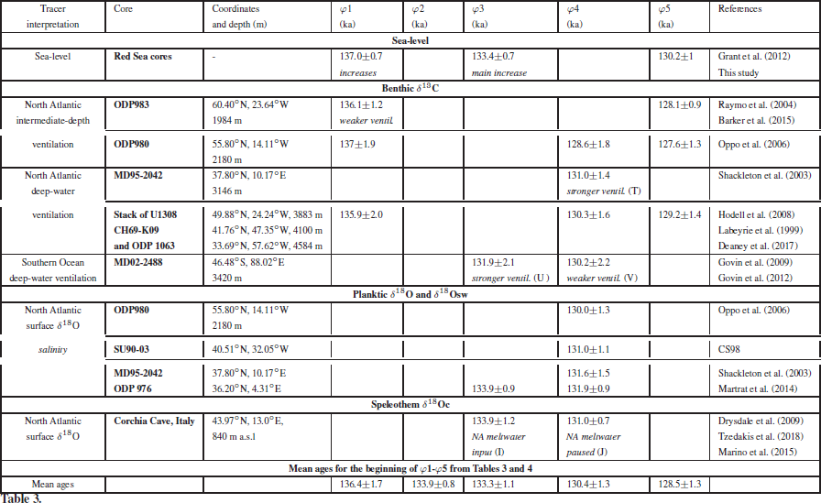 | 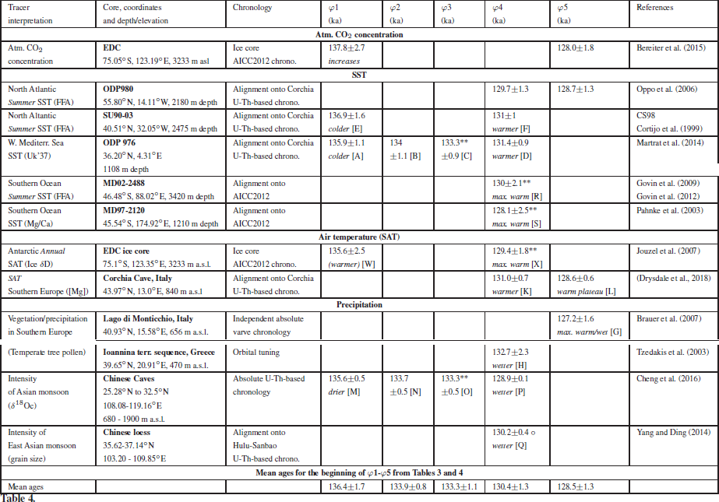

Data
You will find below the data mentioned in Table 3, Table 4, Figure 8 and Figure 9 of the GMD paper
The data files have a version string (_vYYmmDD) in their file name, indicating when they have been uploaded to this site (in case we have to update them later and use a more recent version/date).
You can also check that you have the correct version of the files by computing their checksums (md5sum data_file) and comparing them to the checksums in the table below. Getting a different checksum means that you either have a wrong version of the file, or that the file content was corrupted during the transfer
Data | version  string | md5sum
CH69-K09 (txt) | _v190201 | 4f4edfba575324b504beb20ade0b9d28
MD95-2042 (txt) | _v190201 | cc24515a1a59417486e80155c4ebbbaa
ODP976 (txt) | _v190201 | 6958069100a8df8fde00dd06e0f9bd52
ODP980 (txt) | _v190201 | c8310b4db60415e055c131d57b6cfd56
ODP983 (txt) | _v190201 | e7cb293ceb7b7f7a8771206ec794c938
ODP1063 (txt) | _v190201 | bb075a7f8fe8ffb9bd3778d6584c3924
SU90-03 (txt) | _v190201 | 445ea11f144843ceb7f8128df5fafaf6
SL_LIG_Dutton2017 (txt) | _v190201 | c1151b63ae7c720e7b5b6b3ff2f2451a
d13Cstack (txt) Stack of U1308, CH69-K09 and ODP1063 | _v190201 | d44b91b35fbf6e2e142dd749200b68e4
IRD-stack (txt) | _v190201 | 51bf8dd9d019bf76e3a983eddf35782e
Figure 9 data (xlsx) | _v190213 | 9ec7aae777fdce6e1447a93054622f2c

References cited
- Ayako Abe-Ouchi, F. Saito, K. Kawamura, M. Raymo, J. Okuno, K. Takahashi, and H. Blatter: Insolation-driven 100,000-year glacial cycles and hysteresis of ice-sheet volume, Nature, 500, 190–193, 2013, doi:10.1038/nature12374
- Berger, A.: Long-Term Variations of Daily Insolation and Quaternary Climatic Changes, J. Atmospheric Sci., 35(12), 2362–2367, doi:10.1175/1520-0469(1978)035<2362:LTVODI>2.0.CO;2, 1978.
- Robert D. Briggs , David Pollard , Lev Tarasov, A data-constrained large ensemble analysis of Antarctic evolution since the Eemian, Quaternary Science Reviews, Volume 103, 1 November 2014, Pages 91–115, doi:10.1016/j.quascirev.2014.09.003
- Kageyama, M., Braconnot, P., Harrison, S. P., Haywood, A. M., Jungclaus, J., Otto-Bliesner, B. L., Peterschmitt, J.-Y., Abe-Ouchi, A., Albani, S., Bartlein, P. J., Brierley, C., Crucifix, M., Dolan, A., Fernandez-Donado, L., Fischer, H., Hopcroft, P. O., Ivanovic, R. F., Lambert, F., Lunt, D. J., Mahowald, N. M., Peltier, W. R., Phipps, S. J., Roche, D. M., Schmidt, G. A., Tarasov, L., Valdes, P. J., Zhang, Q. and Zhou, T.: PMIP4-CMIP6: the contribution of the Paleoclimate Modelling Intercomparison Project to CMIP6, Geosci. Model Dev. Discuss., 1–46, doi:10.5194/gmd-2016-106, 2016.
- P. Koehler and C. Nehrbass-Ahles and J. Schmitt and T.F. Stocker and H. Fischer: A 156 kyr smoothed history of the atmospheric greenhouse gases CO2, CH4, and N2O and their radiative forcing, Earth System Science Data, 9, 363–387, doi:10.5194/essd-9-363-2017, 2017.
- Lev Tarasov, Arthur S. Dyke, Radford M. Neal and W.R. Peltier, A data-calibrated distribution of deglacial chronologies for the North American ice complex from glaciological modeling, Earth and Planetary Science Letters, Volumes 315–316, 15 January 2012, Pages 30–40, doi:10.1016/j.epsl.2011.09.010
- Veres, D., Bazin, L., Landais, A., Toyé Mahamadou Kele, H., Lemieux-Dudon, B., Parrenin, F., Martinerie, P., Blayo, E., Blunier, T., Capron, E., Chappellaz, J., Rasmussen, S. O., Severi, M., Svensson, A., Vinther, B. and Wolff, E. W.: The Antarctic ice core chronology (AICC2012): an optimized multi-parameter and multi-site dating approach for the last 120 thousand years, Clim Past, 9(4), 1733–1748, doi:10.5194/cp-9-1733-2013, 2013.

